EPS Learning:

*Customer Order Confirmation Emails with Backorder Status*

Functional Consultant: Dax

Technical Consultant: Jaira

## Summary

### Issue: An email needs to be sent to the transaction contact with an attached PDF containing the backordered quantities of the Items.

### Solution: An email will be sent automatically upon creation of an Item Fulfillment regardless if it's created via the NetSuite UI or via Web Services.

## Solution Design

* When an Item Fulfillment is created for a Sales Order, an email is sent to the Contact's Email address with a PDF attachment of all Sales Order Items, and their quantity shipment details.
* The email sent can be found under the Messages tab of the Item Fulfillment:

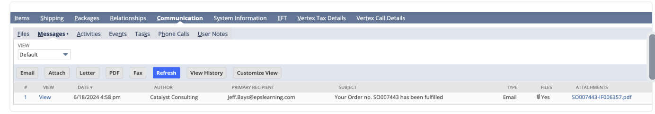

* Sample PDF attachment: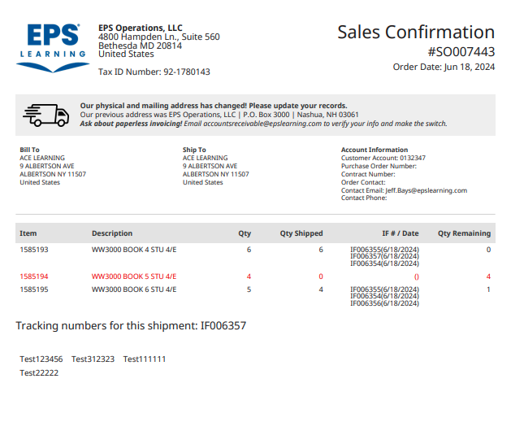

## Customization Components

### **Transactions**

* + Item Fulfillment

### **Fields**

* + Contact's Email [id: *custbody_mhi_contact_email*] (on Sales Order)

### **Scripts**

Instance: SB-1

1. [CTC | Send Email Confirmation UE](https://9086923-sb1.app.netsuite.com/app/common/scripting/script.nl?id=2405&id=2405&whence=)
   * Deployed on Item Fulfillment record.
   * AfterSubmit:
     + On CREATE/COPY, the script will render the Sales Order PDF containing the items, quantity shipped details and tracking numbers. This script sends an email along with this PDF to the Contact's Email found in the related Sales Order record.

### **Email Template**

* + [Item Fulfilment Email Template](https://9086923-sb1.app.netsuite.com/app/crm/common/merge/emailtemplate.nl?id=25)
  + Used by the UE script in formatting the Email to be sent to the contact.

### **PDF Templates and Transaction Forms**

* + Used by the User Event in formatting the PDF attachment of the email.
  1. [EPS | Sales Order | Email Confirmation](https://9086923-sb1.app.netsuite.com/app/common/custom/advancedprint/pdftemplate.nl?id=124&nl=F&tt=SalesOrd&pt=TRANSACTION&source=T&savedsearchid=-1&rt=&e=T&sc=-90)